# Install Python

Create below directory

C:\APP\python

Download python from below link

[https://www.python.org/ftp/python/3.6.0/python-3.6.0-amd64.exe](https://meet.google.com/linkredirect?authuser=0&dest=https%3A%2F%2Fwww.python.org%2Fftp%2Fpython%2F3.6.0%2Fpython-3.6.0-amd64.exe)

## Run installer

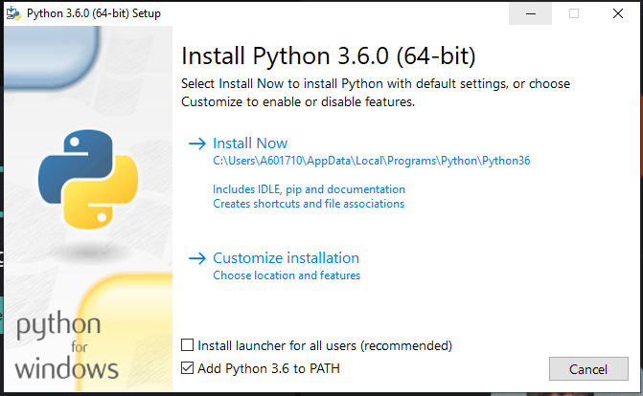

Select “**Add Python 3.6 to PATH**”

Select “**Customize installation**”

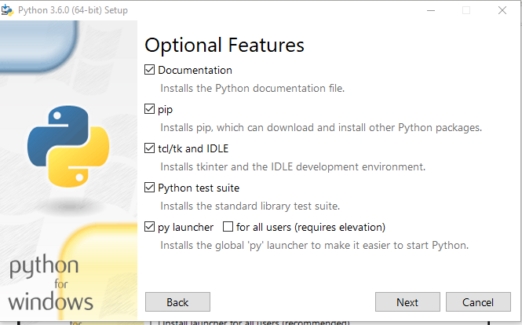

Click on “**Next**”

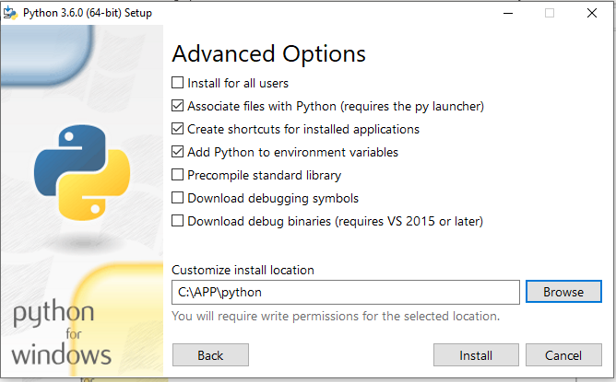

Provide customize path as “**C:\APP\python**” and then Click on “**Install**”

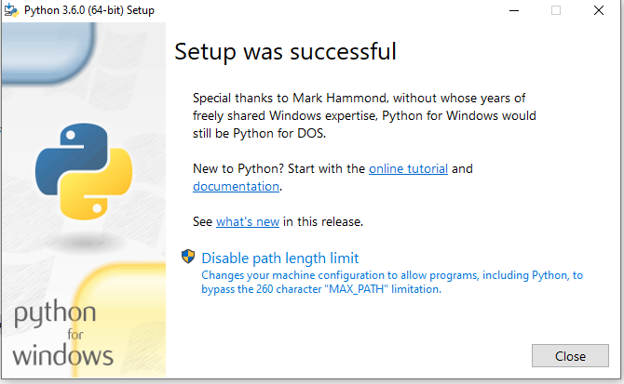

Click on “**Close**”

## Install IDE for Python

## Create below directory

C:\APP\vscode

## Download VS code from below link and extract it.

[https://az764295.vo.msecnd.net/stable/17299e413d5590b14ab0340ea477cdd86ff13daf/VSCode-win32-x64-1.47.2.zip](https://meet.google.com/linkredirect?authuser=0&dest=https%3A%2F%2Faz764295.vo.msecnd.net%2Fstable%2F17299e413d5590b14ab0340ea477cdd86ff13daf%2FVSCode-win32-x64-1.47.2.zip)

Extract above zip file inside “**C:\APP\vscode**”

Install extension for Python

Select Python Interpreter.